Three Standard Reporting Tools in Epic
By Simon Parker-Shames, MPH
7/30/2019

Introduction:
There are three standard reporting tools that are available in most implementations of Epic. Most organizations pick a tool for a given data need based on the resources they have available and the amount of local control over Epic they have. The objective of this document is to give a brief overview of these tools and their pros and cons. Briefly, the three standard tools are:
- Slicer Dicer: A simple, ad-hoc, self-service reporting tool developed primarily to allow providers to analyze their own patient populations. It’s useful for getting simple summaries of populations without involving specialized IT or Data staff.
- Reporting Workbench: A template-based reporting tool inside of Epic that allows clinical and administrative staff to generate reports based on simple criteria. It’s useful for generating patient lists and simple graphical reports with limited Data support. Its reports can be drawn into native Epic dashboards.
- Crystal Reports: A robust reporting and data visualization tool that sits outside of Epic. It’s useful for generating reports based on complex criteria but requires significant IT or Data development. Epic puts special emphasis on Crystal integration and can be configured to display Crystal reports inside of Epic.
Additionally, many healthcare organizations have their own improved reporting tools and data warehouses, but the above are common for nearly all Epic-using organizations.

Summary of key features by tool:
Feature | Tool
 | Crystal | Reporting Workbench | Slicer Dicer
Native dashboard creation | Yes | Somewhat | No
Report on custom data elements | Yes | Somewhat | No
Simple interface | No | Somewhat | Yes
Level of IT/Data resources required | High | Moderate | Low
Drill-down to patient-level detail | Yes | Yes | No
Display data over time | Yes | Limited | Very Limited
Self-service reports | Yes | Depends on configuration | Yes
Share reports between systems or sites | Yes | Somewhat | No
Able to generate meaningful opioid reports out-of-the-box | Limited | Not Yet | Not Yet

Pros and Cons of each tool:

Slicer Dicer:
Pros:
- Simple interface
- Empowering for clinical staff
- Does not require extensive IT/Data support
Cons:
- Access often limited to providers or a single staff type
- Limited query complexity
- Is a black box (results difficult to validate)
Summary: Useful for generating simple ad-hoc queries with low overhead in environments without extensive IT/Data resources. Empowering for clinical staff but limited in capabilities.

Reporting Workbench:
Pros:
- Relatively simple to learn
- Some ability to generate data over time
- Moderate flexibility and complexity
- Easy to take action on patient-level data
Cons:
- May require extensive vendor configuration to be fully usable
- Limitations on query complexity and data-over-time
Summary: Useful as a moderate-complexity reporting tool with tight integration in Epic. Most Epic dashboards are generated primarily from Reporting Workbench reports.

Crystal Reports:
Pros:
- Ability to report on precisely defined, complex criteria (using SQL and other query languages)
- Robustly handle data-over-time
- Share reports between systems (with some modification)
- Create visual summaries and patient-level detail
- When deeply integrated into Epic, allows distribution of dashboards to clinical staff inside Epic
Cons:
- Requires substantial Data/IT resources and extensive collaboration between IT and clinical staff
- Can be time-consuming, complex, and expensive
- May be inferior to 3rd party warehousing and visualization tools that lack standard Epic integrations
Summary: Crystal reports is useful to systems that have extensive resources committed to a project, substantial data/IT resources available, and enough time to rigorously test and validate data. It tends to be the highest overhead but is generally the most powerful.

Appendix: Screenshots and Examples

Epic Dashboard Launcher:
Example Epic Hospital Quality Dashboard Report:
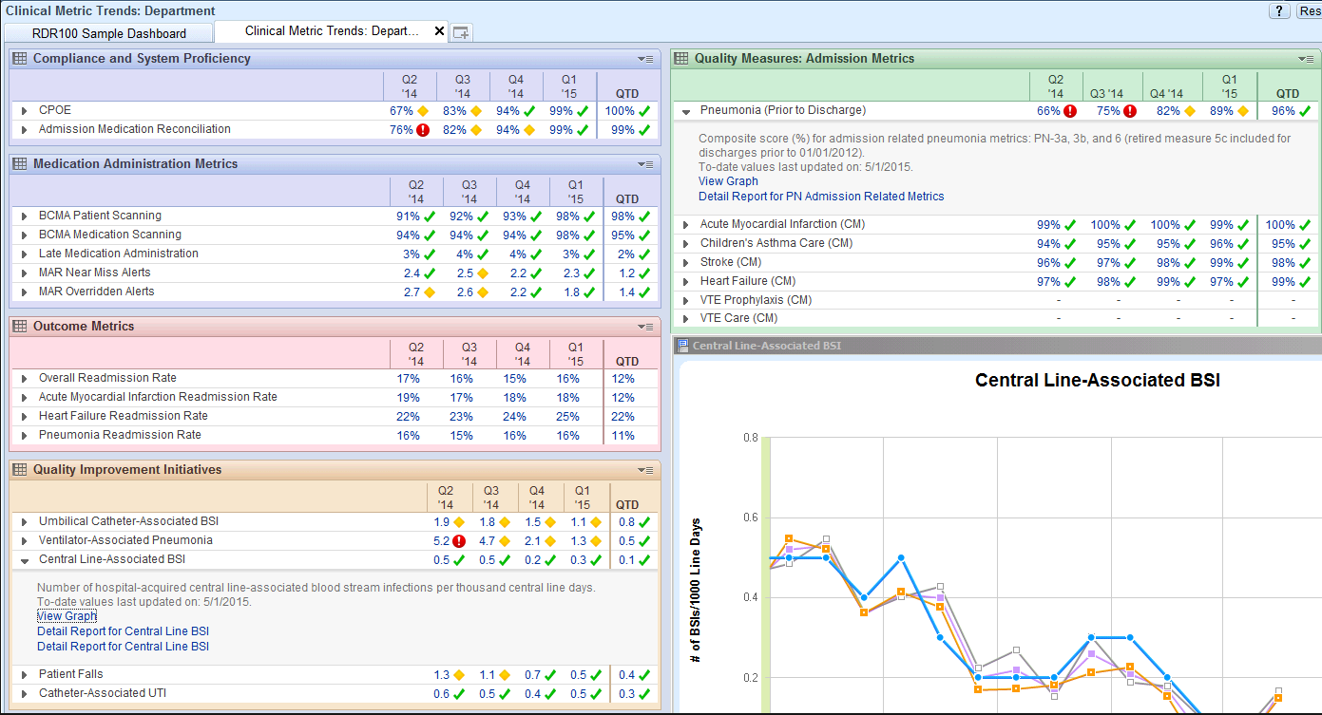
Note that many of the sub-reports in this example are Reporting Workbench reports combined into this dashboard, but it can draw data from multiple other sources (but not, at this time, Slicer Dicer).

Slicer Dicer:
Example Slicer Dicer bar graph:
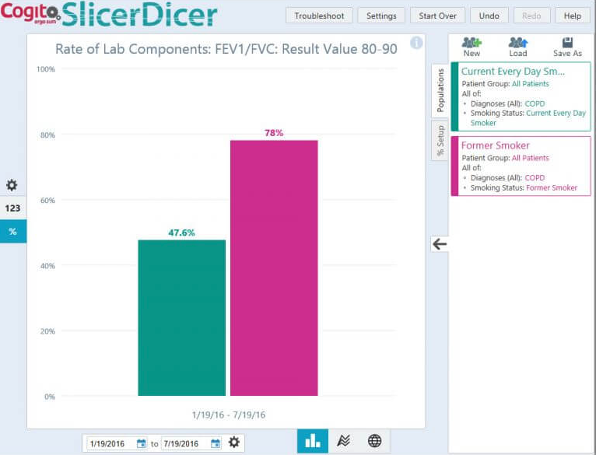
Shows smoking status of patients who had an FEV1 between 80 and 90 between January through July of 2016.

Reporting Workbench:
Example of a simple patient list style report:
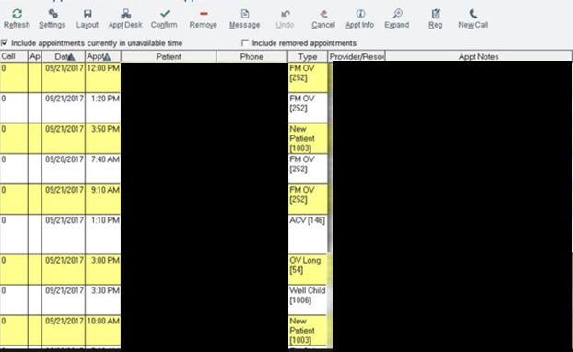
Example Reporting Workbench Line Graph style report:
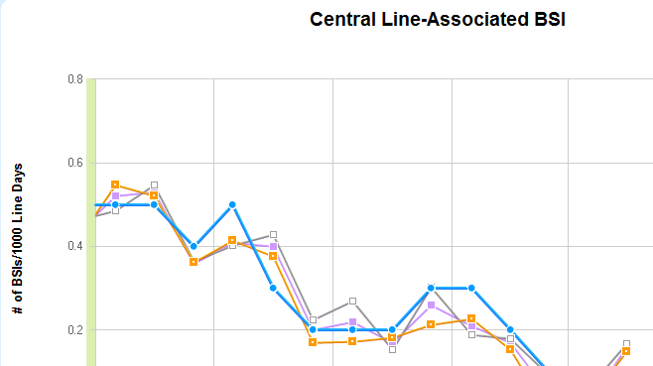

Crystal Reports:
Example of a (non-medical) Crystal Reports Dashboard:
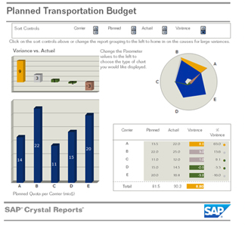
Example of a Crystal Report with summary and detail:
